

**Your Name:**

**School:**

**Form:**

**Ruchugi Test Comments and Questions**

The goal of this exercise is to write the comments and questions you have about responses from students in Canada. The second goal of this exercise is to check a box stating if you thought the response was “Expected” or “Unexpected”. Put an X in the brackets next to either “Expected” or “Unexpected” and write any comment or question you have about the response below under “Comment OR Question”.

**QUESTION: What do you do for fun?**

**EXAMPLE**



**[ ] EXPECTED [ X ] UNEXPECTED**

**COMMENT OR QUESTION**

What do you mean by playing with your puppy?

**Question 1: What do you do for fun?**



**[ ] EXPECTED [ ] UNEXPECTED**

**COMMENT OR QUESTION**

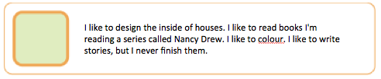

**[ ] EXPECTED [ ] UNEXPECTED**

**COMMENT OR QUESTION**

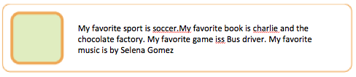

**[ ] EXPECTED [ ] UNEXPECTED**

**COMMENT OR QUESTION**

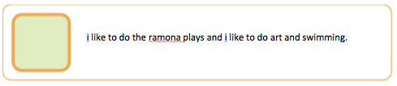

**[ ] EXPECTED [ ] UNEXPECTED**

**COMMENT OR QUESTION**

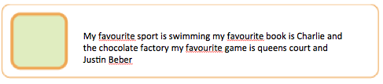

**[ ] EXPECTED [ ] UNEXPECTED**

**COMMENT OR QUESTION**



**[ ] EXPECTED [ ] UNEXPECTED**

**COMMENT OR QUESTION**